 | FACULTY OF COMPUTER SYSTEMS & SOFTWARE ENGINEERING |  |  |  |  | MARKS:  /10
 | COURSE: Database Systems |  | CODE: BCI2023 |  |  | MARKS:  /10
 | TOPIC: Create Table, Insert, Display and List |  |  |  |  | MARKS:  /10
 | ASSESSMENT: Lab Sheet | NUM: 2 |  |  | DURATION: 2 hours | MARKS:  /10
MATRIC NUM: _______________________________ |  |  |  | IC NUM: ________________________________

Attention:
- Create table for Student Information based on the figure above and use the appropriate data types for each column.
- Answer all questions based on the table you have created.
- Shows the answer in SQL command and print screen all results.
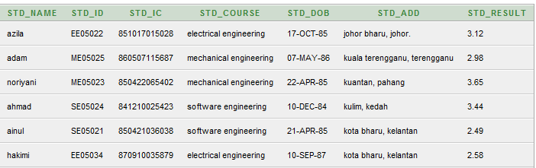
Figure 1: Student Information Table
- Display all students’ name from the student information table.
- Display all students’ name and course order by result.
- List all students’ name, course and result where the results should greater than 3.00.
- Display all records from “software engineering” or “electrical engineering” course.
- Display all records from “software engineering” and “electrical engineering” course.
- Display the student’s name and course where the result between 2.50 to 3.50.
- List all students’ name who has registered in Software Engineering and Mechanical Engineering course.
- List all students who have registered in Electrical Engineering course.
- List all records where the first character in student’s course is S.

